Docker Task

Task Description:

Install docker on EC2 and explore the docker commands (docker images, containers, volumes, network)

Created EC2 :

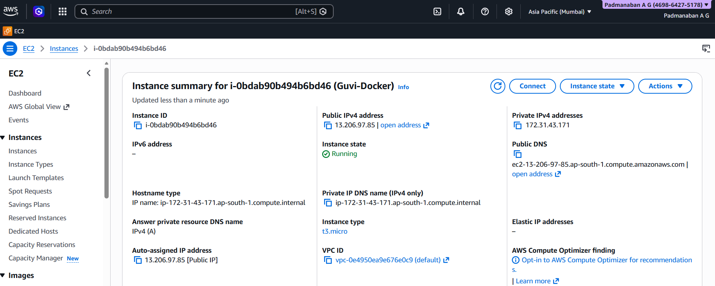

Verification Docker installation :
- Installed Docker :

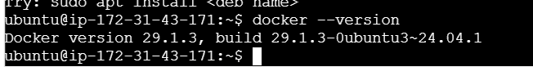

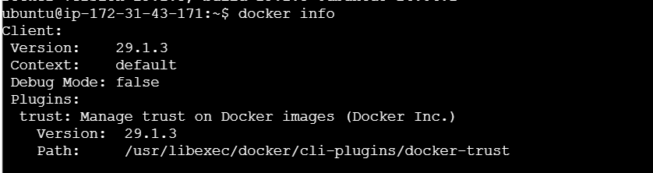

- Tested with print Hello-world

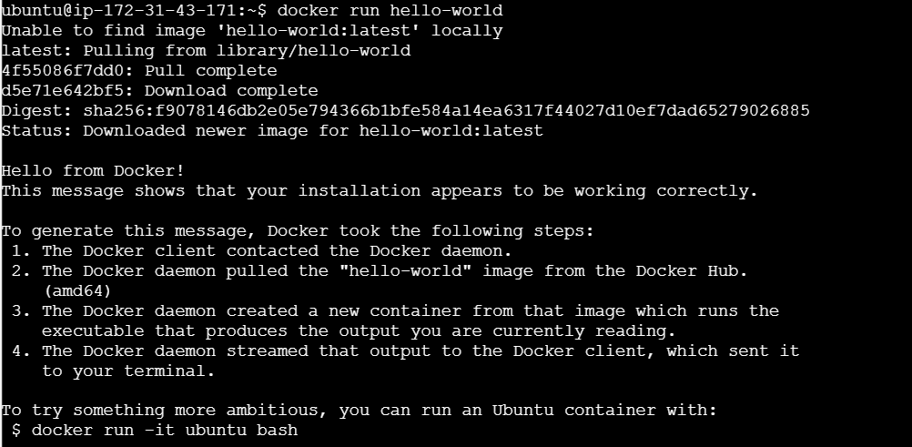

Explore Docker Images
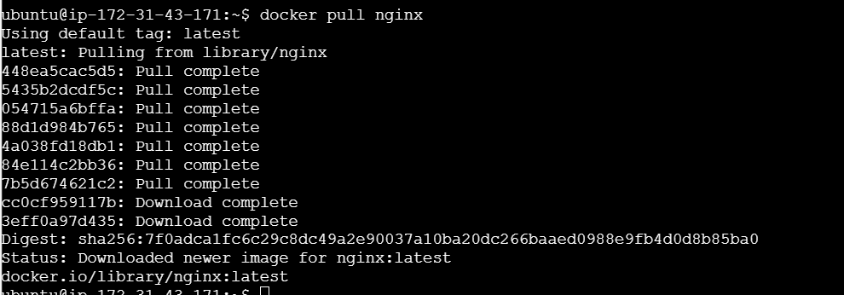
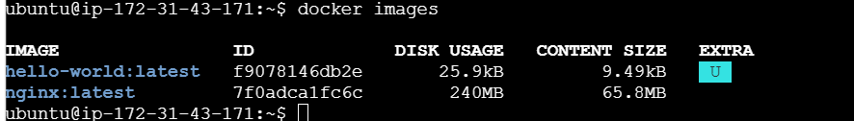

Removed container Image:

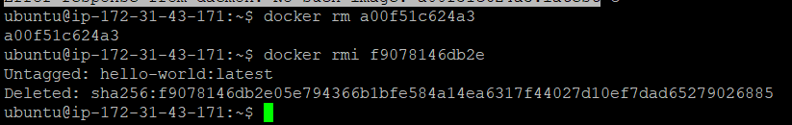

Work with Containers :

- Start a container

- List running containers
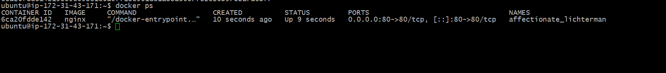

- Stop a container
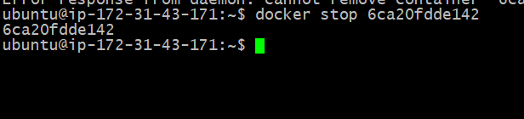

- Remove container
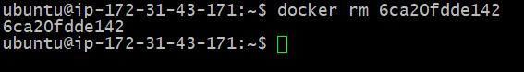

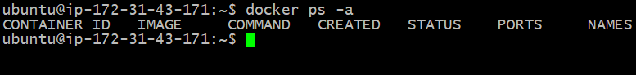

Use Volumes
- Create Volume
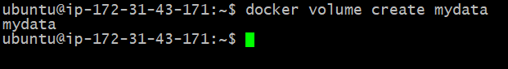

- Inspect Volume
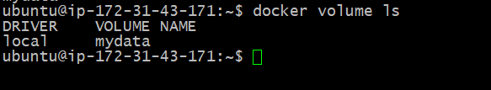
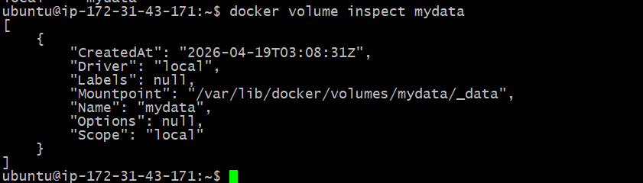
- Mount Volume
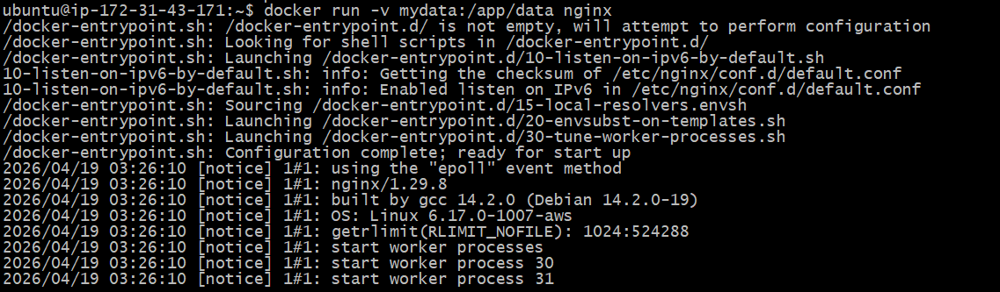

Explore Networks
- List Networks
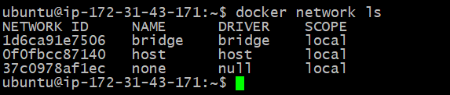
- Create Networks
- Run container in network
- Inspect network
